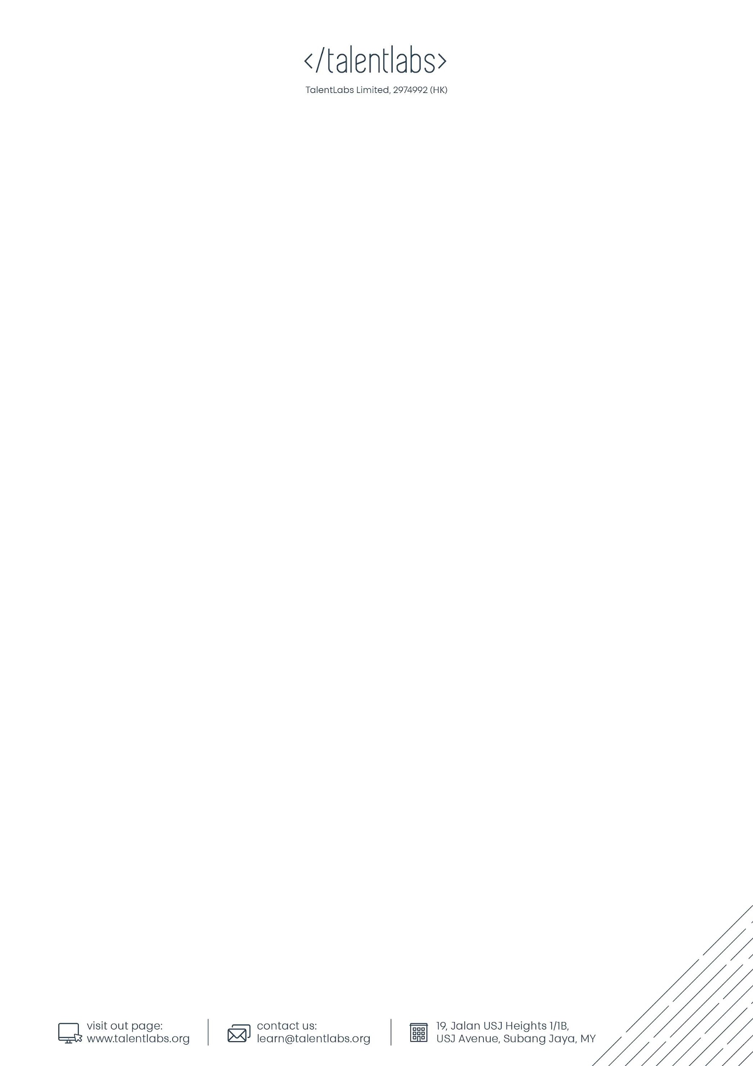Lab 1 Your First Python Program

## Instructions

1. You can edit this file online (No copy is needed)
2. For each of the answers, please fill in your answers in the designated space
3. For submission, please submit it through to the Talentlabs learning platform.

## Part 1 Setting up your development environment

### 1.1 Install the necessary softwares

In this section, you are going to set up your computer to install the necessary software for developing in Python.

1.1.1 Install Visual Studio Code

Visual Studio Code is a code editor for software engineers. It is built by Microsoft and available for everyone for free. The idea of “code editor for software” is similar to “Microsoft Word to documents”.

Steps:

1. Go to the official website(<https://code.visualstudio.com/>) of Visual Studio Code to download the latest version of Visual Studio Code installer.

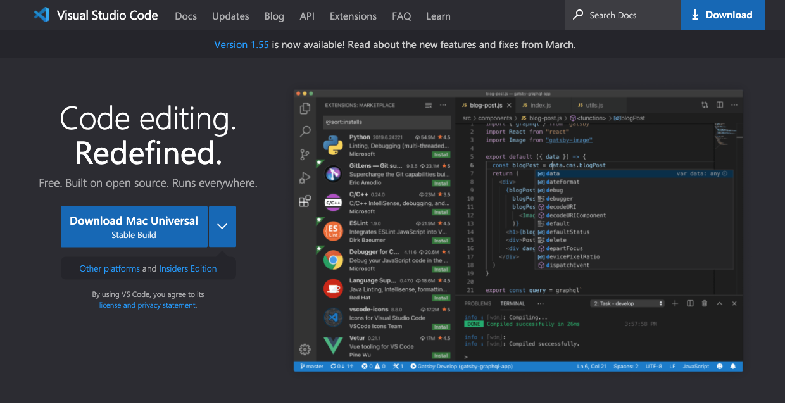

1. Once it is downloaded, run the installer (VSCodeUserSetup-{version}.exe). This will only take a minute. You can just leave all the options as-is.
2. By default, VS Code is installed under C:\users\{username}\AppData\Local\Programs\Microsoft VS Code.

1.1.2 Setup your Visual Studio Code for Python

Steps:

1. Open the “Extension” panel by clicking on the fifth icon on the left.

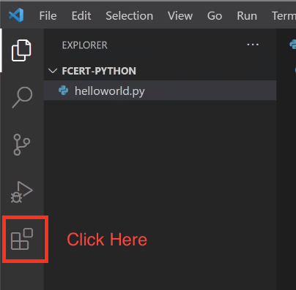

1. In the search bar, type “Python” and install the “Python Extension”.

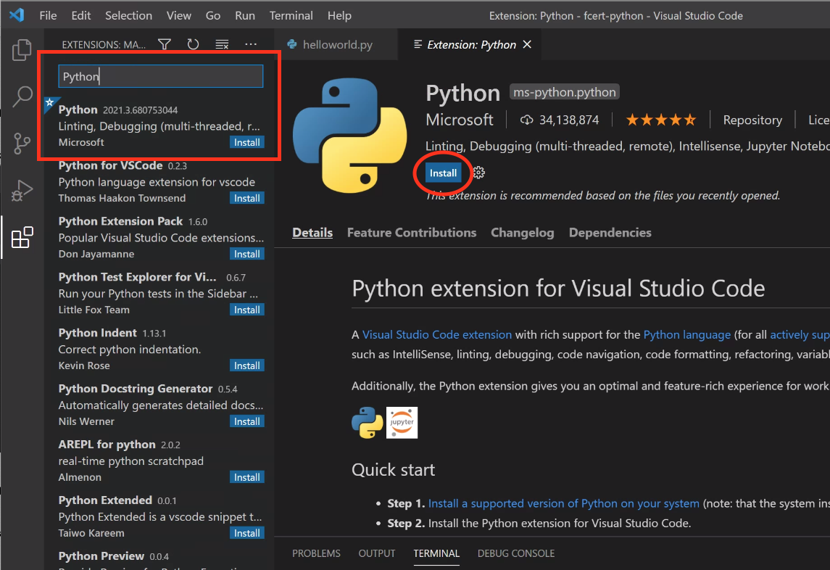

1. Wait for the installation process to finish.
2. Open a terminal in Visual Studio Code by clicking “View -> Terminal”

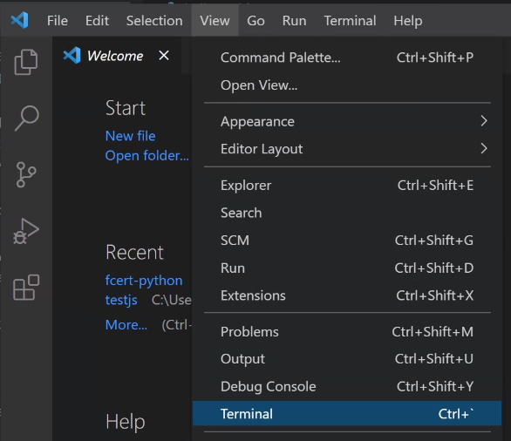

1. In the terminal opened at the bottom of VSCode, type “python” and press enter. If the setup is successful, then you should see something like the following screenshot (Python 3.x.x).

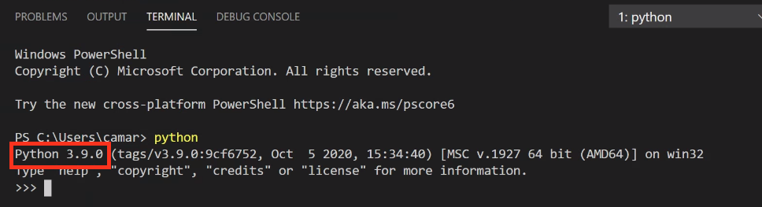

1. If the above step is not successful, install python in the step 7
2. Download Python Windows installer here:

<https://www.python.org/ftp/python/3.9.4/python-3.9.4-amd64.exe>

1. In the installation step, click “**Customized Installation**”
2. Make sure you selected “**Add Python to environment variables**”

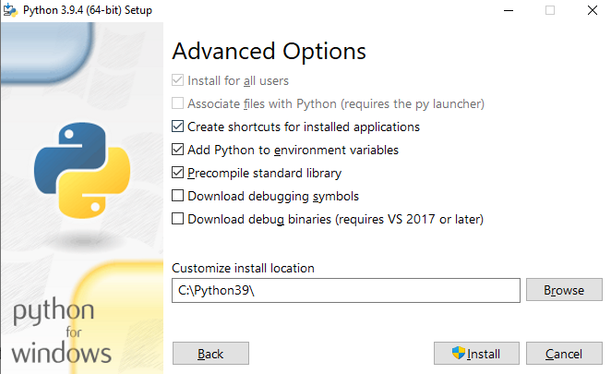

1. After the installation, **restart the VSCode** and try step 4 ~ 5 again, and you should see this:



Task 1.1.3 Try running your first python program in VSCode

Steps:

1. Pick any place on your computer, and create a new folder and name it as “testpython”.
2. Open the Visual Studio Code software and pick “Open Folder”

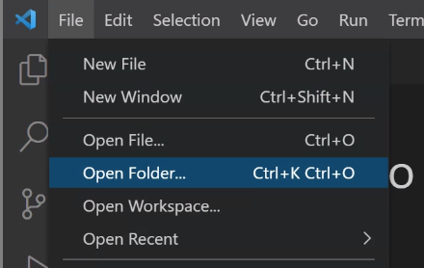

1. Then pick the folder you just created.

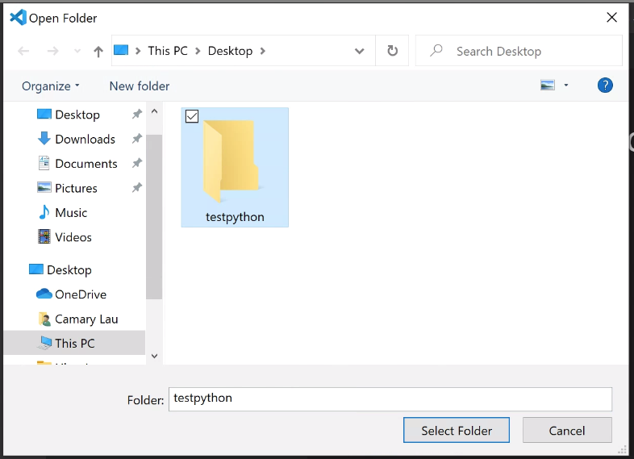

1. Create a new file in this folder by clicking the “New File” button.

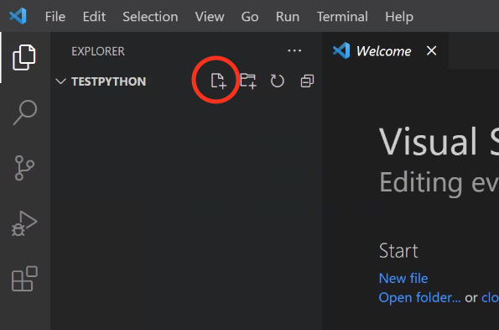

1. Give the new file name as “helloworld.py”. It should look like something like the screenshot below.

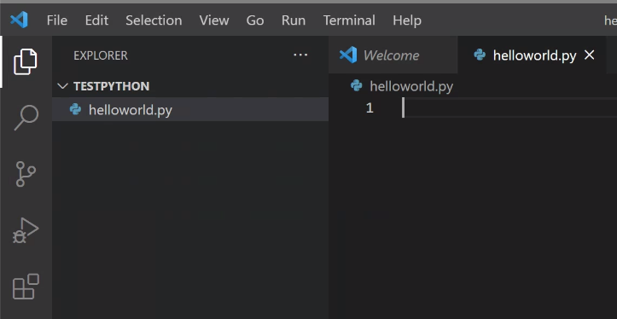

1. In the helloworld.py file, type in the following code.

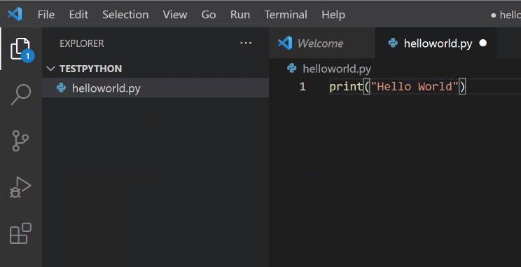

1. Then click “Run -> Run Without Debugging”

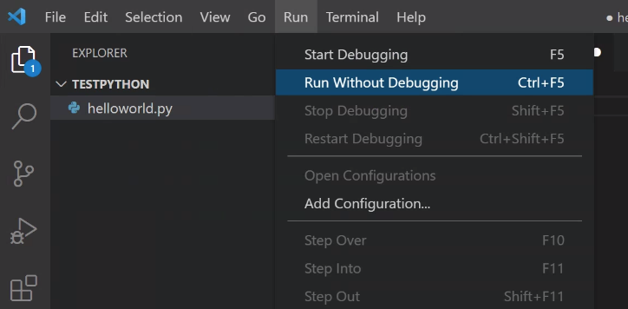

1. If it is successful, then you should see the output at the bottom of the window.

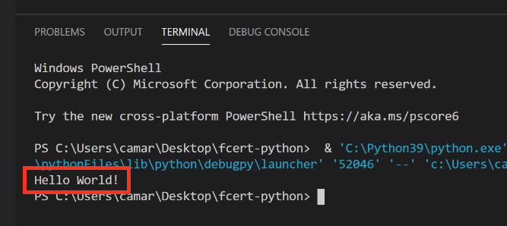

## Part 2 Build a greeting python program

### Your task is to build a program where the computer would talk to the user and ask for their name and age. Then, the computer should respond by telling the user about their age next year with their name.

### A sample interaction would be something like the following:

### 

### 2.1 Ask for user’s name and age

You can use print() and input() commands to ask for the user's name and age, then store the user input into variables.

You can reference the lecture notes on how to collect user input.

### 2.2 Greet the user and calculate his/her age next year

You should use the print() command to greet the user and use the str() with int() to calculate the user's age next year.

## Part 3 Submission

### Zip the whole file and upload the file to the Talentlabs learning platform.